Sleepez

Web322 Assignment 3

Christopher Kelly

Ckelly28@myseneca.ca

Kadeem Best



**Table of contents:**

Introduction……………………………………………………………………………………………..……………2

Login Form………………………………………………………………………………………………....………...2

Server Side Validation…………………………………………………………………………….…...………..2

User Account Creation…………………………………………………………………………………………..3

Responsive Design…………………………………………………………………………………..…………….4

**Introduction:**

Part 3 of this assignment had us incorporate a database into our website as well add server side validation for registration

**Login Form:**

Renders a separate page where the user inputs an e-mail and password and gets redirected to a dashboard (Currently under construction)

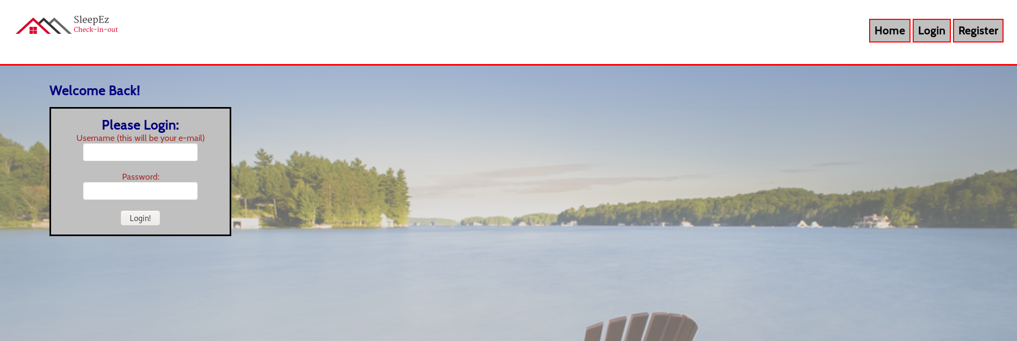

**Server Side Validation:**

In app.js, the server validates a completed form for registration and login. For Registration, the user is valid if:

-Age is over 18 (based on birthday)

-Name is not null

-Password uses upper and lower case letters, a number, and is between 8 and 16 characters.

~~-E~~mail is validated as well, and goes through additional validation through mongoDB to see if the email is unique.

Incorrect Password:

~~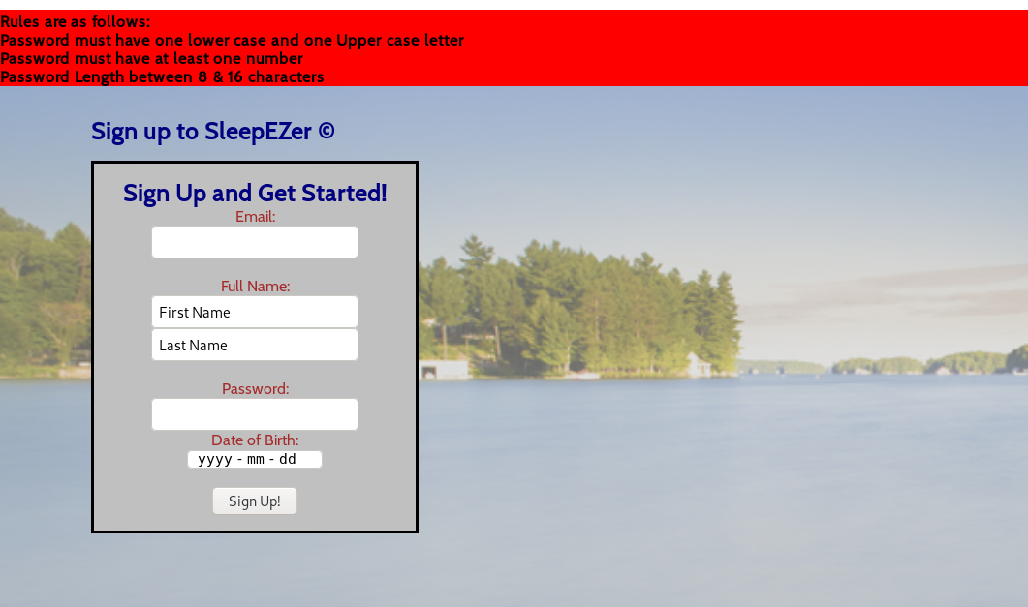~~

Email already in use:

~~~~

**User Account Creation:**

As mentioned, user account creation has been setup using a mongoDB schema that requires a unique e-mail. In the user registration POST, as long as everything has been validated, a welcome e-mail is sent to the user and the user is redirected to a static dashboard:

~~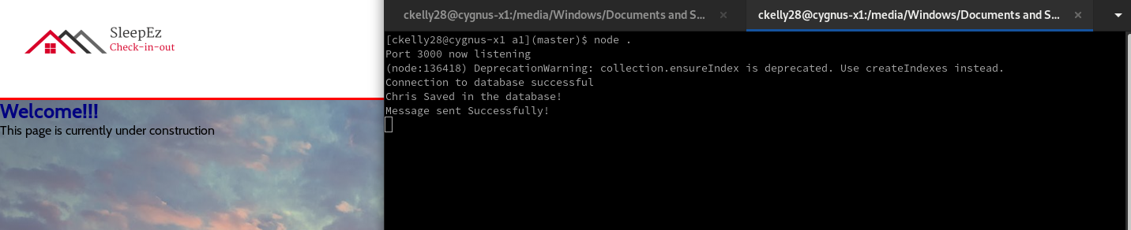~~

mongoDB:

~~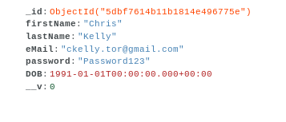~~

eMail:

~~~~

**Responsive Design:**

Many elements were made smaller, or set to display as block as well as changes made to the padding and margin at smaller sizes.

Menu was left in for tablets but changes to a vertical list when screen size goes below 600 px.

Video:

~~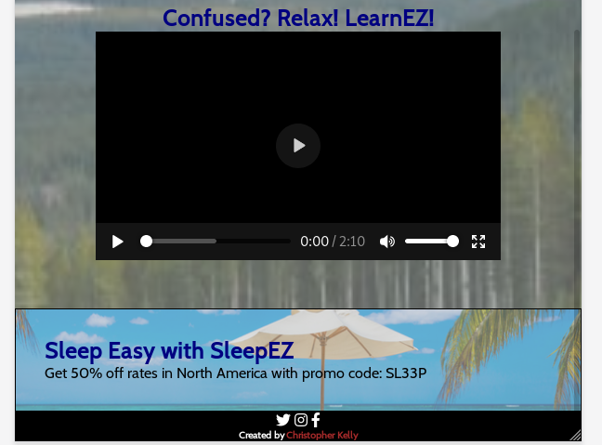~~

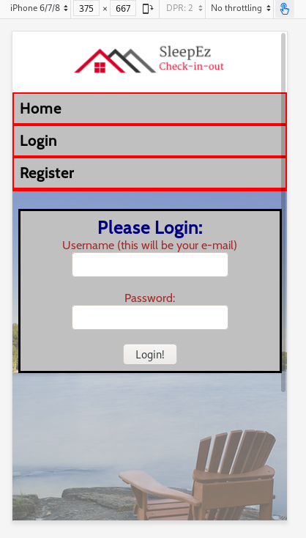Forms: